TEMPLATE NOTES — READ THEN DELETE THIS BOX BEFORE SUBMITTING ANYTHING
Rebuilt Oct 11, 2026 from your 30-split Colab run (multiseed_results.csv, mechanism_table.csv, lambda_sweep.csv). Every number in the tables and in the factual sentences is generated from those files. Gray italic text is for you: write the interpretation paragraphs, the Discussion, the Conclusion and the Abstract’s finding in your own words, then delete the gray text. Check before you keep them: the Related Work descriptions (written from abstracts and definitions only, so read FaiR-N’s Table 3, RAGUEL and von Kügelgen et al. yourself) and the AI-assistance paragraph before the References, which must describe what you actually did. Nothing in this draft claims to be first: related work on this question exists (Section 2).

Does Group Fairness Guarantee Recourse Fairness? An Empirical Test Across Two Decision Domains
[Your Name]
Independent Research — October 2026

Abstract
Automated decision systems are commonly audited with group fairness metrics such as demographic parity and equalized odds, which compare outcome or error rates across protected groups. Work on algorithmic recourse asks a different question: for a person who receives an unfavorable decision, how large a change would be needed to receive a favorable one? We measure how two standard bias mitigation methods, Reweighing and a covariance-penalized logistic regression, change the recourse gap between groups. We use linear classifiers, for which the distance to the decision boundary has an exact closed form, on two public datasets from different decision domains: Adult Census Income (protected attribute: sex) and COMPAS recidivism data (race). Groups are compared with Mann–Whitney U tests and rank-biserial effect sizes. Every experiment is repeated over 30 random train/test splits, and two robustness checks are added: removing the protected attribute from the model’s inputs, and sweeping the penalty strength.
[FINDING, yours to write. What the 30 splits show: on Adult, Reweighing and the covariance penalty reach almost the same group fairness (mean SPD −0.087 vs −0.094; on every split they differ by at most 0.014 in SPD and 0.027 in AOD) but leave recourse gaps of opposite sign (mean r = 0.205 vs −0.083; Reweighing’s is larger on all 30 splits, by 0.27 to 0.30). With the protected column removed from the model’s inputs, Reweighing cuts |SPD| from 0.180 to 0.095 yet moves r only from 0.311 to 0.293. On COMPAS the gap is small (mean r 0.059 to 0.083) and individually significant in only 2 to 7 of 30 splits per method; with about 120 vs 363 denied people the test reaches 80% power only for |r| of about 0.17 or more.]
[IMPLICATION: one or two sentences. What an audit that checks only SPD and AOD can and cannot tell you from these results, inside the limits of Section 6 (two datasets, linear models, the protected column as a model input).]

1. Introduction
Suppose a bank uses a machine learning model to decide who receives a loan. Regulators, and increasingly the public, ask whether that model is fair. In practice, “fair” almost always means one specific thing: that people from different protected groups (for example, defined by sex or race) are approved at similar rates, or are denied in error at similar rates. These are the group fairness metrics, demographic parity and equalized odds, that dominate both the academic fairness literature and common audit practice.
There is a second, quieter question that group fairness metrics do not answer. Among the people a model denies, how close were they to being approved? If a denied applicant in one group would need only a small, plausible change to flip to approved, while a denied applicant in another group would need a much larger change, something unequal is happening that group-level rate comparisons cannot see. This is the question addressed by the algorithmic recourse literature: for a given individual, what is the minimum-cost change to their features that would flip an unfavorable prediction to a favorable one (Ustun et al., 2019)? Prior work has proposed defining fairness directly in terms of this recourse cost, requiring that the average distance to a favorable outcome be similar across protected groups (Gupta et al., 2019; Sharma et al., 2020).
The two notions are conceptually distinct, and prior work argues that fairness of recourse is complementary to fairness of prediction (von Kügelgen et al., 2022). A model can, in principle, deny two groups at identical rates while consistently placing one group’s denied members much closer to the decision boundary than the other’s. Because group-level rates are the most widely used fairness checks, a classifier that passes them could still leave one group a harder path to a favorable outcome, unmeasured by the check that certified it as fair.
This paper asks an empirical question about standard tools: when a classifier is modified with a standard bias mitigation method until its group fairness metrics improve, what happens to the recourse gap between groups? We test two methods that act at different stages of the pipeline, Reweighing (pre-processing) and a covariance-penalized logistic regression (in-processing), on two public datasets from different decision domains, and we repeat each experiment over 30 random splits so that no result rests on a single train/test split. Two robustness checks address threats we found in our own design: the protected attribute is an input to the models, and the penalty method’s training objective is closely tied to the recourse measure (Section 3.5).

2. Related Work

Group fairness.
Most technical work on machine learning fairness defines fairness as a statistical property of a model’s outcomes across protected groups. Demographic parity requires equal rates of favorable prediction across groups; equalized odds requires equal true and false positive rates across groups (Hardt, Price, & Srebro, 2016). These definitions, and the toolkits built around them, treat fairness as a property of aggregate rates rather than of any individual’s path to a favorable outcome.

Algorithmic recourse.
A separate literature asks what an individual, rather than a group, would need to do to change an unfavorable outcome. Ustun, Spangher, and Liu (2019) formalized recourse for linear classifiers as an integer-programming problem and showed, on credit-scoring data, that recourse can be significantly affected by standard choices in model development.

Fairness of recourse.
Several papers ask whether recourse is distributed fairly across groups. Gupta, Nokhiz, Roy, and Venkatasubramanian (2019) proposed measuring recourse fairness as the average distance to the decision boundary of the people given an unfavorable outcome, compared across groups, together with a regularizer that equalizes it. Sharma, Gee, Paydarfar, and Ghosh (2020) give the same definition (their Definition 1) and propose FaiR-N, a training method for neural networks. von Kügelgen et al. (2022) argue that fairness of recourse is complementary to fairness of prediction and propose group- and individual-level criteria that account for causal relationships between features. Guldogan et al. (2023) propose equal improvability, which asks that rejected individuals in different groups have the same chance of being accepted after a bounded effort to improve their features, and contrast it with demographic parity. van Rosmalen et al. (2022) assess a counterfactual-distance metric (“burden”) against statistical parity and report that the two can disagree about which group is treated unfairly. Haldar, Cunningham, and Ferhatosmanoglu (2022) report that traditional fair classifiers can exacerbate recourse unfairness and propose RAGUEL, a recourse-aware re-ranking method. Artelt and Hammer (2022) propose a model-agnostic method for generating counterfactual explanations whose recommended actions have similar complexity across groups.
[Before keeping this paragraph: read FaiR-N’s Table 3 (what it compares, on which datasets and models), RAGUEL and von Kügelgen et al. yourself. The descriptions above come from abstracts and definitions, not from full reads. Fix any sentence a full read contradicts.]

COMPAS and real-world stakes.
The COMPAS recidivism risk tool became a central case study in algorithmic fairness after Angwin, Larson, Mattu, and Kirchner (2016) reported that Black defendants who did not reoffend were substantially more likely than white defendants to have been labeled higher risk. That investigation was framed in terms of group error rates. We use COMPAS here as a second decision domain, with race binarized as Caucasian versus all other recorded groups (the AIF360 default); this is not a claim about how the tool is used in practice.

This work.
The papers above establish that group fairness and recourse fairness are different properties and that methods aimed at one need not deliver the other. We do not claim to be first. This study is a narrow, reproducible replication and extension: it uses linear models, for which the distance to the decision boundary is exact; it compares groups with rank-based tests and effect sizes; it repeats every experiment over 30 random splits; it tests Reweighing, a standard pre-processing method, next to a covariance-penalized logistic regression; and it adds two checks, with the protected column removed and with the penalty strength swept, that probe how the recourse gap moves.
[Before posting: finish a systematic literature search (Google Scholar and Semantic Scholar; “cited by” on Gupta et al. 2019 and von Kügelgen et al. 2022) and check whether FaiR-N or RAGUEL already evaluate Reweighing. Add anything you find here.]

3. Methods

3.1 Datasets
We use two public, widely studied datasets, loaded through the AI Fairness 360 toolkit (AIF360; Bellamy et al., 2018) with its default preprocessing. Adult Census Income (Adult) is a 1994 U.S. Census extract; the task is predicting whether annual income exceeds $50,000, which is the favorable outcome, and the audited attribute is sex (male = privileged, 30,527 instances; female = unprivileged, 14,695). COMPAS is ProPublica’s recidivism data from Broward County, Florida; the task is predicting two-year recidivism, the favorable outcome is no recidivism, and the audited attribute is race, binarized by AIF360 as Caucasian (privileged, 2,100) versus all other recorded groups (unprivileged, 4,067). After AIF360’s preprocessing Adult has 45,222 instances (3,620 rows with missing values removed) and COMPAS has 6,167. Each experiment uses an 80/20 random train/test split and is repeated over 30 splits: seed 42, the split used during development, plus seeds 0 to 28.

3.2 Baseline Model
For both datasets we train an L2-regularized logistic regression (scikit-learn, default C = 1, at most 2,000 iterations) on standardized features (zero mean and unit variance, fitted on the training split only). Standardization was necessary for reliable optimizer convergence on Adult and puts the margin in Section 3.4 on a common scale across features. We choose a linear model deliberately: the distance from any point to the decision boundary then has an exact closed form, with no approximation error from a counterfactual search. This is a scope decision, not an oversight; Section 6 returns to it. AIF360’s loaders keep both of their default protected attributes (sex and race) as input features in both datasets, so the audited attribute is an input to the primary models. Section 3.7 describes a check that removes it.

3.3 Group Fairness Metrics
We report statistical parity difference, SPD = P(ŷ = favorable | unprivileged) − P(ŷ = favorable | privileged), and average odds difference, AOD = ½[(FPR_{u} − FPR_{p}) + (TPR_{u} − TPR_{p})], where u and p index the unprivileged and privileged groups, the favorable outcome is treated as the positive class, and all rates are computed on the test split. Zero indicates parity, and a negative SPD means the unprivileged group receives the favorable outcome less often. Both are computed with a short numpy function that we checked against AIF360’s ClassificationMetric.

3.4 Recourse (Margin) Metric
For a linear classifier with weight vector w and bias b, the signed distance from an instance x to the decision boundary is margin(x) = (w · x + b) / ‖w‖₂, computed in the standardized feature space. For every test instance the model predicts as unfavorable (“denied”), the recourse cost is |margin(x)|, the smallest Euclidean change in the standardized features that would flip the prediction. We compare the costs of denied members of the privileged and unprivileged groups. We do not condition on whether a denial was correct: recourse is a property of what the deployed model asks of an individual, independent of whether the prediction matches the true label. The audited attribute cannot be changed by the individual, but excluding it from the movable coordinates multiplies every cost in a given model by the same constant, ‖w‖ divided by the norm of w without that coordinate, which cannot change a rank-based comparison; we therefore compute the margin over all coordinates.

3.5 Bias Mitigation Methods
Reweighing (Kamiran & Calders, 2012) is a pre-processing method that gives each training instance a weight so that group membership and label are statistically independent in the weighted training data; the classifier is then trained with those weights. Our second method is a covariance-penalized logistic regression. It minimizes the mean logistic loss plus 10⁻³‖w‖² plus λ·C², where C is the sample covariance between the protected attribute and the raw decision score w · x + b, and λ = 5. This is the decision-boundary covariance proxy of Zafar et al. (2017), used as a penalty rather than a constraint. We implemented it directly, optimizing with L-BFGS-B and an analytic gradient, instead of using AIF360’s PrejudiceRemover, which wraps an external reference implementation and does not expose its fitted weights, so the margin in Section 3.4 could not be computed from it. Both methods keep a linear decision function.
The penalty method is not independent of the recourse measure. The margin is the same raw score divided by ‖w‖, so a penalty that pulls the groups’ mean scores together acts on margins directly. Reweighing is the cleaner test of whether group-fairness mitigation moves recourse; the penalty method shows what happens when the training objective is closely coupled to the margin.
λ = 5 was chosen from a four-value sweep (0, 1, 5, 20) on COMPAS, judged by SPD and accuracy on the same held-out split later used for reporting, and then reused unchanged on Adult. It was not tuned toward any recourse number. Section 4.5 reports a sweep over seven values.

3.6 Statistical Testing
Recourse costs are skewed, and Shapiro–Wilk tests rejected normality for every group and method on the seed-42 split (all p < 10⁻¹⁰), so we use the two-sided Mann–Whitney U test throughout. As effect size we report the rank-biserial correlation r = 1 − 2U / (n_{p}n_{u}), where U is the statistic for the privileged group’s costs, so r > 0 means the unprivileged group’s costs tend to be larger. (1 + r) / 2 is the probability that a randomly chosen denied unprivileged person is farther from the boundary than a randomly chosen denied privileged person, ignoring ties. We test at α = 0.05 within each split. Because the 30 splits overlap (each shares most of its data with the others), the spread of r across splits describes sensitivity to the split, not a confidence interval for a population effect. We therefore report the mean and the middle 95% of the 30 values, and the number of splits with p < .05 and with r < 0, and do not pool p-values.

3.7 Robustness Checks
Protected column removed. We repeat all runs after removing the audited attribute from the model’s inputs. The penalty and the sample weights still use it during training. The other protected attribute that AIF360 keeps as a feature (race in Adult, sex in COMPAS) stays in the model. Penalty strength. We train the covariance-penalized model with λ ∈ {0, 1, 2, 5, 10, 20, 50} on the first 10 splits. Power. For COMPAS we simulate the power of the Mann–Whitney test at the observed group sizes, using a normal-shift model that produces a stated r (2,000 simulated datasets per value).

4. Results
Results are reported separately for each dataset, followed by a comparison across both. Each value is the mean over 30 random splits, with the middle 95% of the 30 values in brackets. Denied counts are means over splits. Recourse costs are in standardized-feature units. In Sections 4.1 and 4.2 the audited attribute is a model input.

4.1 Adult Income
Table 1. Group fairness before and after each intervention, Adult (sex). Mean over 30 splits [middle 95%].
Model | Statistical parity difference | Average odds difference | Accuracy
Baseline | −0.186 [−0.198, −0.176] | −0.091 [−0.117, −0.061] | 0.847 [0.841, 0.852]
Reweighing | −0.087 [−0.102, −0.076] | 0.068 [0.043, 0.089] | 0.841 [0.834, 0.849]
Covariance-penalized LR | −0.094 [−0.109, −0.082] | 0.057 [0.035, 0.080] | 0.840 [0.832, 0.848]

Table 2. Recourse statistics by group, Adult. Cost = |margin| of denied test instances; r is the mean over 30 splits [middle 95%], and r > 0 means the unprivileged group (women) is farther from the boundary.
Model | Denied (priv. / unpriv.) | Mean cost, priv. | Mean cost, unpriv. | Recourse gap r | Splits with p < .05 | Splits with r < 0
Baseline | 4,486 / 2,705 | 0.895 | 1.386 | 0.426 [0.403, 0.450] | 30/30 | 0/30
Reweighing | 4,778 / 2,554 | 0.949 | 1.132 | 0.205 [0.183, 0.233] | 30/30 | 0/30
Covariance-penalized LR | 4,782 / 2,576 | 1.294 | 1.087 | −0.083 [−0.107, −0.056] | 30/30 | 30/30

The recourse gap is statistically detectable on every split for all three models (p < .05 in 30, 30 and 30 of 30), but its direction and size depend on the method. In probability terms, a randomly chosen denied woman is farther from the decision boundary than a randomly chosen denied man with probability 0.71 at baseline, 0.60 after Reweighing and 0.46 after the covariance penalty. On the same 30 splits, Reweighing and the penalty differ by at most 0.014 in SPD and 0.027 in AOD, while their recourse gaps differ by 0.27 to 0.30, with Reweighing’s larger on every split. Mean AOD changes sign under both methods (−0.091 at baseline, 0.068 and 0.057 after). Using |SPD| and |AOD| below 0.1 as a common rule of thumb for “group-fair” (not a standard), Reweighing passes both checks on 28 of 30 splits and leaves |r| ≥ 0.1 on 28 of those; the penalty passes on 25 of 30 and leaves |r| ≥ 0.1 on 3.
[Interpretation, 1–2 paragraphs, yours. Facts to account for: both methods improve SPD by about the same amount; Reweighing shrinks the gap without closing it; the penalty reverses its sign; the two are indistinguishable on SPD and AOD but far apart on r. Say what a group-fairness audit certifies in that situation, and keep the claim inside Section 6.]

4.2 COMPAS
Table 3. Group fairness before and after each intervention, COMPAS (race). Mean over 30 splits [middle 95%].
Model | Statistical parity difference | Average odds difference | Accuracy
Baseline | −0.159 [−0.218, −0.101] | −0.139 [−0.207, −0.080] | 0.667 [0.643, 0.687]
Reweighing | −0.010 [−0.059, 0.067] | 0.014 [−0.038, 0.089] | 0.663 [0.644, 0.686]
Covariance-penalized LR | −0.078 [−0.133, −0.011] | −0.056 [−0.113, 0.014] | 0.666 [0.646, 0.686]

Table 4. Recourse statistics by group, COMPAS. r is the mean over 30 splits [middle 95%], and r > 0 means the unprivileged group (non-Caucasian defendants) is farther from the boundary.
Model | Denied (priv. / unpriv.) | Mean cost, priv. | Mean cost, unpriv. | Recourse gap r | Splits with p < .05 | Splits with r < 0
Baseline | 121 / 364 | 0.563 | 0.599 | 0.083 [−0.007, 0.163] | 7/30 | 2/30
Reweighing | 160 / 318 | 0.541 | 0.607 | 0.059 [−0.023, 0.158] | 5/30 | 3/30
Covariance-penalized LR | 141 / 336 | 0.543 | 0.555 | 0.059 [−0.006, 0.149] | 2/30 | 2/30

On COMPAS the baseline gap is small: mean r = 0.083, positive on 28 of 30 splits and individually significant on 7. The single split used during development (seed 42) gave r = 0.012, lower than 26 of the 30 split values, so the earlier single-split reading of “no recourse gap on COMPAS” belongs to that split and not to the dataset. Reweighing brings mean SPD to −0.010 and the penalty to −0.078; mean r is 0.059 and 0.059, individually significant on 5 and 2 of 30 splits. With about 120 and 363 denied people (medians), the Mann–Whitney test has 38% power for a true r of 0.10, 70% for 0.15 and 92% for 0.20, and reaches 80% at about 0.17. A non-significant COMPAS split is therefore uninformative about gaps below roughly that size.
[Interpretation, 1–2 paragraphs, yours. What can and cannot be said about COMPAS given the power numbers above? Do not write “no gap”; write what the data can rule out.]

4.3 Cross-Dataset Comparison
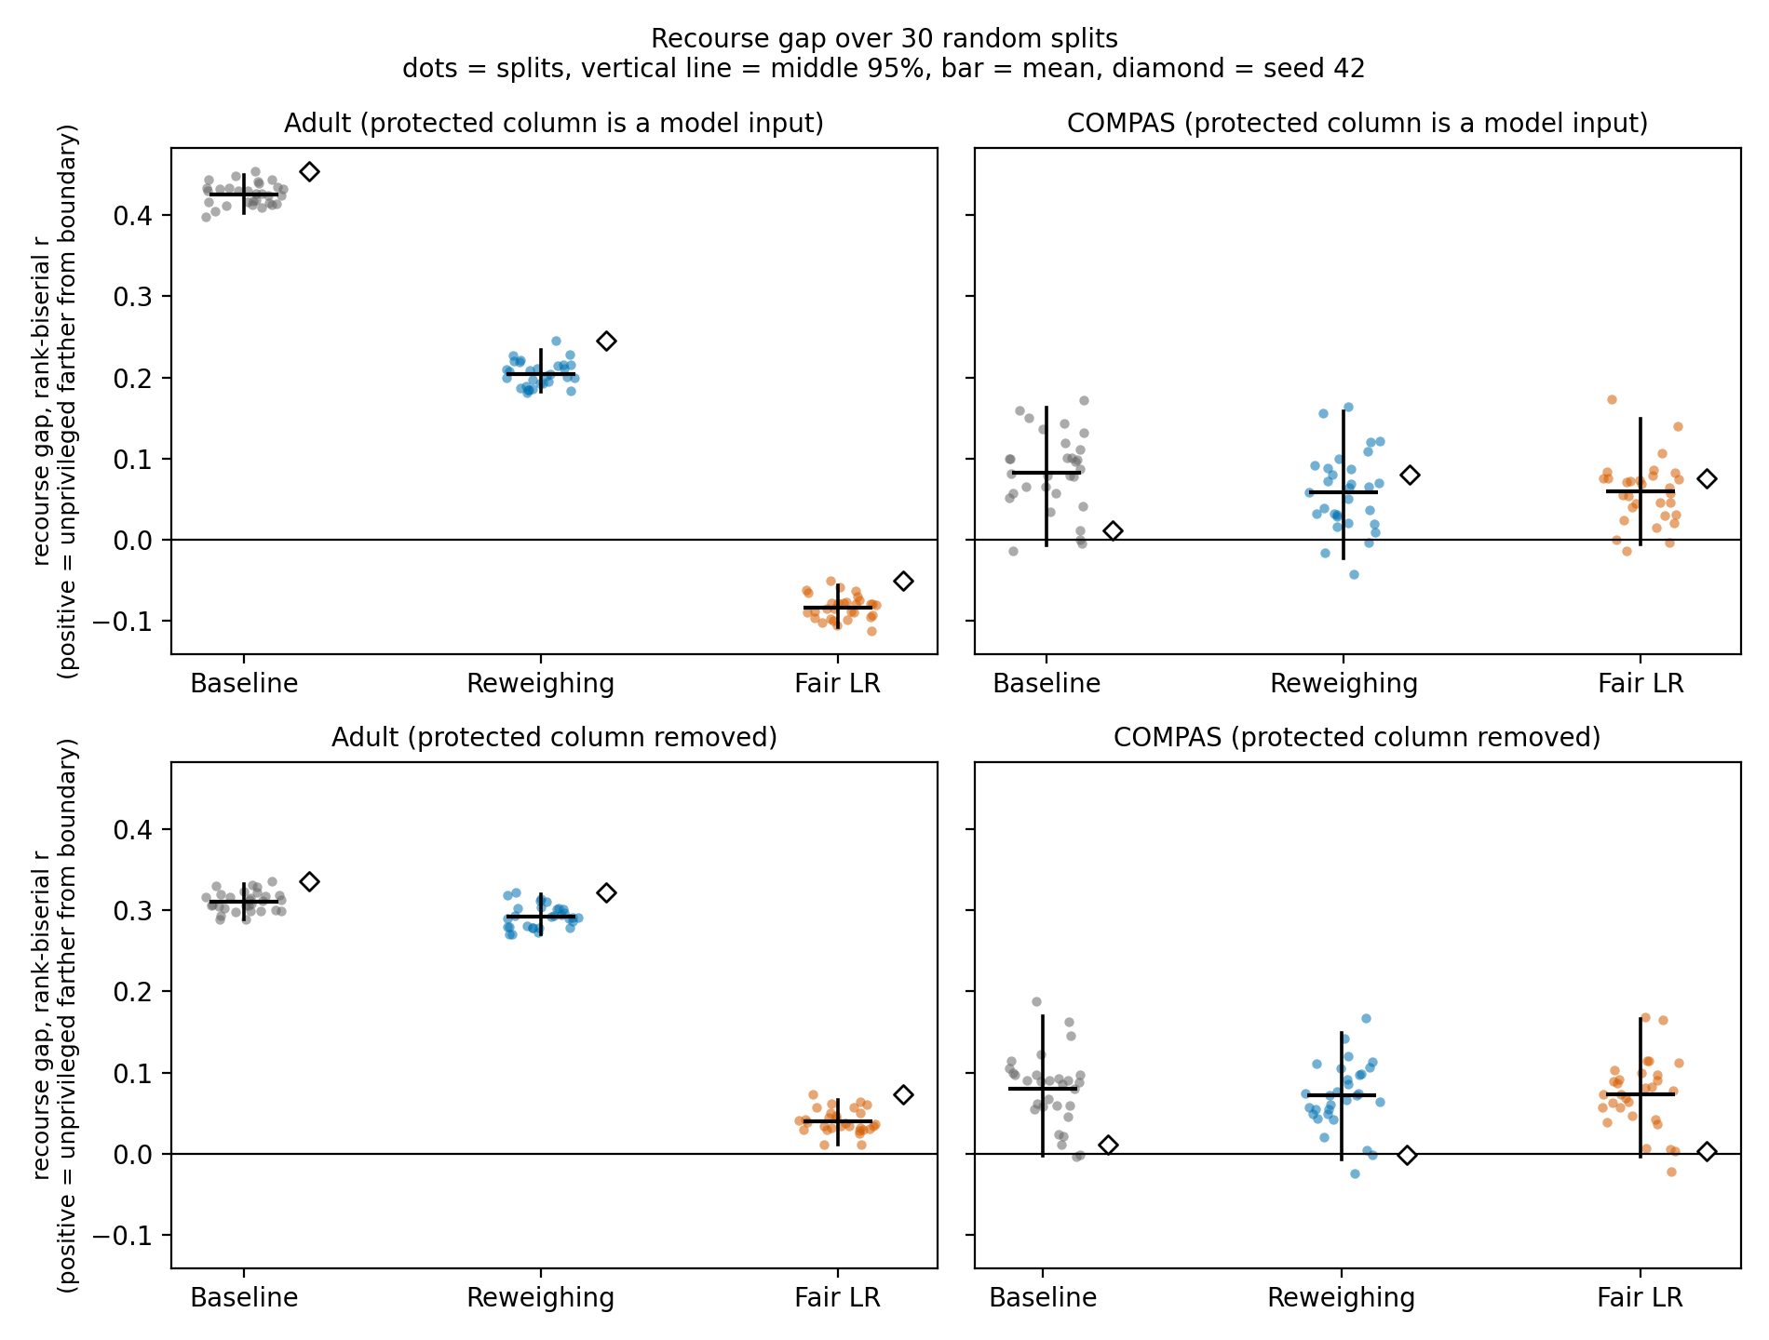
Figure 1. Recourse gap (rank-biserial r) over 30 random splits. Top row: the audited attribute is a model input (Sections 4.1–4.2). Bottom row: it is removed from the model’s inputs (Section 4.4). Dots are splits, the vertical line is the middle 95%, the horizontal bar is the mean, and the diamond is the single split (seed 42) used during development.
On Adult the three methods are separated by 0.22 to 0.51 in mean r, while the spread across splits within a method is at most 0.016 (standard deviation). On COMPAS the three methods overlap completely, and the middle 95% of every cell includes or touches zero.
[Interpretation, yours. Does the answer to “does fixing group fairness fix recourse?” differ between the datasets, and can you tell whether that is the domain, the size of the baseline gap, or just sample size (see the COMPAS power numbers)?]

4.4 Protected Column Removed, and Where the Mitigation Acts
Table 5. The same models with the audited attribute removed from the model’s inputs. Means over 30 splits; r with the middle 95%. The last column repeats the mean r from Tables 2 and 4 for comparison.
Data | Model | SPD | AOD | r, column removed | r, column kept
Adult | Baseline | −0.180 | −0.078 | 0.311 [0.289, 0.333] | 0.426
Adult | Reweighing | −0.095 | 0.057 | 0.293 [0.271, 0.320] | 0.205
Adult | Covariance-penalized LR | −0.048 | 0.115 | 0.040 [0.011, 0.066] | −0.083
COMPAS | Baseline | −0.154 | −0.134 | 0.080 [−0.002, 0.170] | 0.083
COMPAS | Reweighing | −0.147 | −0.127 | 0.072 [−0.007, 0.149] | 0.059
COMPAS | Covariance-penalized LR | −0.148 | −0.128 | 0.073 [−0.004, 0.166] | 0.059

Table 6. Where the mitigation acts (audited attribute kept as an input; means over 30 splits). Weight share is the audited attribute’s coordinate divided by ‖w‖, signed so that a positive value favors the privileged group. Margins are signed so that positive means toward the favorable decision, over all test instances.
Data | Model | Weight share | Mean margin, priv. | Mean margin, unpriv. | Margin SD, priv. | Margin SD, unpriv.
Adult | Baseline | 0.119 | −0.448 | −1.214 | 1.317 | 0.977
Adult | Reweighing | −0.088 | −0.560 | −0.887 | 1.313 | 0.978
Adult | Covariance-penalized LR | −0.355 | −0.836 | −0.868 | 1.426 | 0.911
COMPAS | Baseline | 0.004 | 0.283 | 0.023 | 0.908 | 0.912
COMPAS | Reweighing | −0.093 | 0.145 | 0.091 | 0.905 | 0.909
COMPAS | Covariance-penalized LR | −0.050 | 0.184 | 0.063 | 0.911 | 0.847

With the audited attribute removed, the baseline gap on Adult falls from r = 0.426 to 0.311. Reweighing then leaves the gap almost unchanged (0.293) while still cutting |SPD| from 0.180 to 0.095, and the penalty brings it to 0.040. On COMPAS, removing the column changes the gap little (mean r 0.080, 0.072, 0.073), and neither method then reduces |SPD| much (from 0.154 to 0.147 and 0.148). With the column kept, the audited attribute’s weight share on Adult moves from 0.119 at baseline to −0.088 under Reweighing and −0.355 under the penalty (Table 6), that is, from favoring men to favoring women. After the penalty the two groups’ mean margins are nearly equal (−0.836 vs −0.868), but their spreads differ (SD 1.426 vs 0.911), and denied men are on average farther from the boundary than denied women (1.294 vs 1.087).
[Interpretation, yours. What does it say about how these two fixes work if one of them stops moving r once the model cannot use the protected column, while SPD still improves? Consider the spreads in Table 6 as well as the means, and say which parts of your explanation are tested here and which are only consistent with the table.]

4.5 Penalty Strength
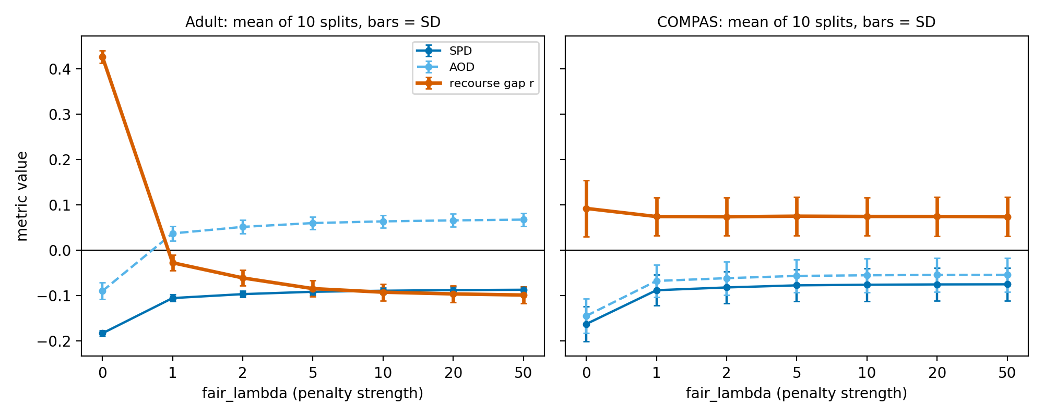
Figure 2. Covariance-penalized logistic regression with penalty strength λ from 0 to 50 (mean of the first 10 splits; bars are standard deviations across those splits). The audited attribute is a model input.
On Adult, mean r falls from 0.427 at λ = 0 (the unpenalized model) to −0.028 at λ = 1 and −0.099 at λ = 50, while mean SPD moves only from −0.106 at λ = 1 to −0.088 at λ = 50. The mean gap is negative for every λ ≥ 1, so the sign change does not depend on λ = 5; its size does. On COMPAS, mean r is 0.092 at λ = 0 and between 0.074 and 0.075 for every λ ≥ 1, while mean SPD moves from −0.163 at λ = 0 to −0.075 at λ = 50.
[Interpretation, one short paragraph, yours. Is the Adult reversal a knob (more penalty, more reversal) or a threshold? What does that mean for calling it “overcorrection”?]

5. Discussion
[Write this section yourself, from Tables 1–6 and Figures 1–2. Questions it has to answer, in order: (1) Two mitigations with nearly the same SPD and AOD leave opposite recourse gaps on Adult. What does that say about what SPD and AOD certify? (2) With the protected column removed, SPD improves a lot under Reweighing while r barely moves. What does that suggest about how these fixes work? (3) What can COMPAS tell us at this sample size? (4) The penalty method is coupled to the margin. How does that limit what the Adult reversal shows? (5) What should an auditor who checks only SPD and AOD take from this, and what would you test next? Keep every claim inside the scope in Section 6. Do not use “first”, “novel” or “no one has”.]

6. Limitations
The audited attribute is a model input. In the primary analysis, AIF360’s loaders keep the audited attribute and the other protected attribute as input features, so a mitigation can act by giving the model a group-specific score offset, that is, by treating the groups differently at decision time. The protected-column run (Section 4.4) removes the audited attribute but not the other protected attribute, and the penalty and the weights still use the audited attribute during training. It does not answer the question for a model that never sees any protected attribute.
The penalty method is coupled to the recourse measure. Its penalty is the covariance between the protected attribute and the raw score, and the margin is that score divided by ‖w‖, so the penalty moves margins by construction. The Adult reversal under this method should be read with that in mind; Reweighing is the cleaner test.
Penalty strength. λ = 5 was picked from a four-value sweep on COMPAS using SPD and accuracy on the same split later used for reporting, then reused on Adult. It was not tuned toward a recourse number. The seven-value sweep (10 splits) shows a negative mean gap on Adult for every λ ≥ 1, with a size that depends on λ (mean r from −0.028 at λ = 1 to −0.099 at λ = 50).
COMPAS power. With about 120 and 363 denied people, 80% power needs |r| of about 0.17. The COMPAS results can neither confirm nor exclude gaps of the size seen at baseline (mean r = 0.083).
Multiple tests and split variability. Each split involves six Mann–Whitney tests with no multiplicity correction; on the seed-42 split a Bonferroni correction (α = 0.05/6) changes no conclusion. The 30 splits overlap, so the middle-95% ranges describe sensitivity to the split and are not confidence intervals for a population effect.
Who is denied changes with the method. The recourse gap is computed among denied people, and mitigation changes who is denied (mean denied on Adult: 4,486 / 2,705 at baseline, 4,778 / 2,554 after Reweighing, 4,782 / 2,576 after the penalty). Comparisons across methods therefore compare different sets of people, and say nothing about any one person’s path to approval.
Linear models and the cost measure. Only linear classifiers are used so that the margin is exact; deployed systems are often nonlinear and would need an approximate recourse measure that might show a different pattern. The cost treats every feature as equally easy to change, includes features that cannot change, and treats one-hot indicators as continuous after standardization (COMPAS has 401 input columns after one-hot encoding, many of them rare charge descriptions). Cost-weighted recourse measures exist and are not implemented.
Scope. Two datasets, two mitigation methods, one binary protected attribute per dataset (Adult: sex; COMPAS: race, binarized as Caucasian versus all others), no intersectional analysis, and one toolkit’s default preprocessing.

7. Conclusion
[One paragraph, yours. Restate the question. State what the data show inside the scope of Section 6: on Adult, two mitigations with almost the same group fairness leave opposite recourse gaps, and the gap’s response depends on whether the model can use the protected column; on COMPAS, not enough power to say. State the practical implication (for example, reporting a recourse measure next to SPD and AOD in audits), and close with the clearest next step (nonlinear models, a recourse-aware or tuned mitigation, more datasets).]

Reproducibility and AI Assistance
Code, outputs and a dated research log are in the project repository (github.com/Aryan-infinite/recourse-fairness): the notebook, multiseed_results.csv (360 fits), lambda_sweep.csv (140 fits), requirements.txt and the figures. The experiments ran in Google Colab with aif360 0.6.1, pandas 2.2.3, numpy 2.1.3, scikit-learn 1.6.1, scipy 1.16.3 and matplotlib 3.10.0. A separate run in a different software environment (numpy 2.5.4, scikit-learn 1.9.1, scipy 1.18.1) reproduced SPD, AOD and accuracy exactly on all 360 fits and the recourse gap r to within 0.0002. Every fit converged.
[AI assistance: edit this so it is accurate. Suggested starting point: The analysis code and first drafts of the Methods and Related Work text were written with Claude (Anthropic). The author ran all experiments, wrote the interpretation, Discussion and Conclusion, and is responsible for every claim. Change the second sentence to say what you actually did.]

References
Angwin, J., Larson, J., Mattu, S., & Kirchner, L. (2016). Machine Bias. ProPublica.
Artelt, A., & Hammer, B. (2022). “Explain it in the same way!” Model-agnostic group fairness of counterfactual explanations. arXiv:2211.14858.
Bellamy, R. K. E., Dey, K., Hind, M., Hoffman, S. C., Houde, S., Kannan, K., Lohia, P., Martino, J., Mehta, S., Mojsilović, A., Nagar, S., Ramamurthy, K. N., Richards, J., Saha, D., Sattigeri, P., Singh, M., Varshney, K. R., & Zhang, Y. (2018). AI Fairness 360: An extensible toolkit for detecting, understanding, and mitigating unwanted algorithmic bias. arXiv:1810.01943.
Guldogan, O., Zeng, Y., Sohn, J., Pedarsani, R., & Lee, K. (2023). Equal improvability: A new fairness notion considering the long-term impact. International Conference on Learning Representations (ICLR). arXiv:2210.06732.
Gupta, V., Nokhiz, P., Roy, C. D., & Venkatasubramanian, S. (2019). Equalizing recourse across groups. arXiv:1909.03166.
Haldar, A., Cunningham, T., & Ferhatosmanoglu, H. (2022). RAGUEL: Recourse-aware group unfairness elimination. ACM International Conference on Information and Knowledge Management (CIKM). arXiv:2208.14175.
Hardt, M., Price, E., & Srebro, N. (2016). Equality of opportunity in supervised learning. Advances in Neural Information Processing Systems (NeurIPS).
Kamiran, F., & Calders, T. (2012). Data preprocessing techniques for classification without discrimination. Knowledge and Information Systems, 33(1), 1–33.
Sharma, S., Gee, A. H., Paydarfar, D., & Ghosh, J. (2020). FaiR-N: Fair and robust neural networks for structured data. arXiv:2010.06113.
Ustun, B., Spangher, A., & Liu, Y. (2019). Actionable recourse in linear classification. Proceedings of the ACM Conference on Fairness, Accountability, and Transparency (FAccT). arXiv:1809.06514.
van Rosmalen, Y., van der Steen, F., Jans, S., & van der Weijden, D. (2022). Bursting the burden bubble? An assessment of Sharma et al.’s counterfactual-based fairness metric. arXiv:2211.11512.
von Kügelgen, J., Karimi, A.-H., Bhatt, U., Valera, I., Weller, A., & Schölkopf, B. (2022). On the fairness of causal algorithmic recourse. AAAI Conference on Artificial Intelligence. arXiv:2010.06529.
Zafar, M. B., Valera, I., Gomez-Rodriguez, M., & Gummadi, K. P. (2017). Fairness constraints: Mechanisms for fair classification. International Conference on Artificial Intelligence and Statistics (AISTATS). arXiv:1507.05259.
[Confirm venue and year for von Kügelgen et al. (AAAI), Guldogan et al. (ICLR) and Zafar et al. (AISTATS) on the publishers’ pages before posting. Titles, authors and arXiv numbers were checked; those three venues were not.]

